Issues in . IT SHOULD BE LIMITED DIGITS in Date picker Text fields.
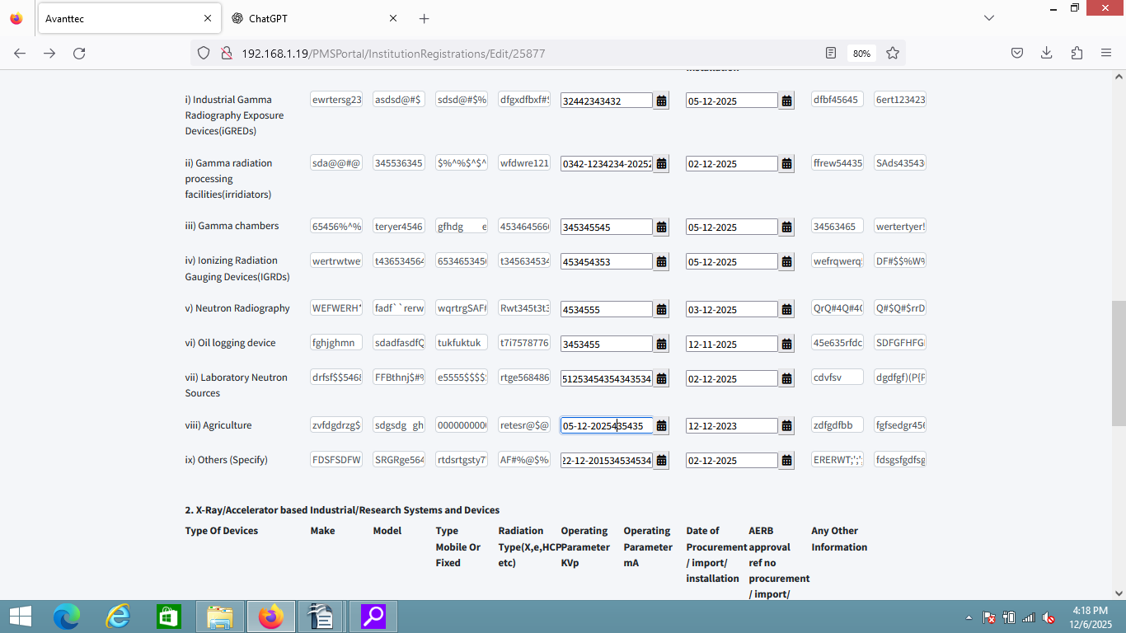
In Radation type DOB should be Limited Digits-MAJOR DEFECT

It should not accept to upload the img-BLOCKER DEFECT

The file name contains the back side of the image- MINIOR DEFECT

In Radation type Start from and End to should be Limited Digits- MAJOR DEFECT.

In Radation type place of birth(State/UT) in -MAJOR DEFECT.
In place of birth if you click the no matches found - no matches found
displayed in Text field
YYYY/MM - it ia accept letter

http://192.168.0.123:8906/Personnel/CreatePersonnel

